Keeping Women in STEM Careers- Fixing the Leaky Pipe

Webinar
February 22nd at 15:00 CET
Together with RESBIOS partner Institut de Ciències del Mar (ICM-CSIC) from Barcelona University of Gdansk is taking part in a discussion on Keeping Women in STEM Careers- Fixing the Leaky Pipe on Feburary 22nd at 15:00 CET
REGISTRATION is needed:
If you are interested in taking part in this discussion please click here to register.
Featuring contributions from:
Prof Doris Elster - Biology and Science Education, University of Bremen- "Interest and Recruitment in Science - Why Women choose STEM Studies"
Prof Natalia Marek- Trzonkowska- International Centre for Cancer Vaccine Science, University of Gdańsk- "Why so few women reach professorship positions in science and how we can change it".
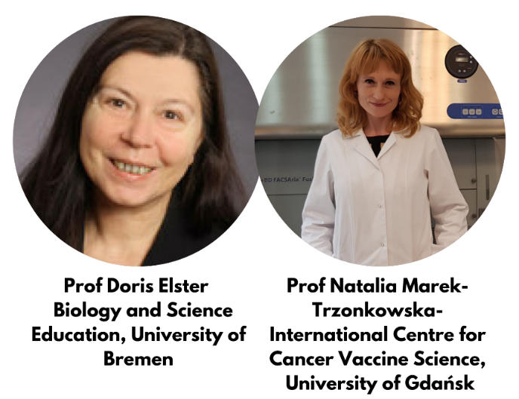
Following these presentation the floor will then be opened for questions and comments from the audience to discuss these issues further and share experiences and collect feedback.
The Webinar will be presented in English and hosted via Zoom. Link and reminder will be timely provided to the registered participants.

